Hands-On
Exercise 6: Proxy Pattern Example
In this module, I have successfully implemented, executed and tested the Proxy Pattern in java and created a project called ProxyPatternExample. I developed an Image interface and a RealImage class that represented images retrieved from a remote server and had a display() method. I created a ProxyImage class that would implement the Image interface and would hold a reference to the RealImage.To optimize performance, I created a ProxyImage class that would implement the Image interface and would hold a reference to the RealImage. The goal of the ProxyImage class was to implement lazy initialization and caching, so that images would only be loaded when needed and reused if they were accessed more than once. Once it was implemented, I ran the program and tested the loading and display of the image using the proxy to ensure that the lazy loading and caching mechanism was working as intended. This hands-on exercise was useful to me to understand the benefits of the Proxy Pattern in terms of application performance, unnecessary resource consumption, and controlled access to resource-intensive objects.
Coding:
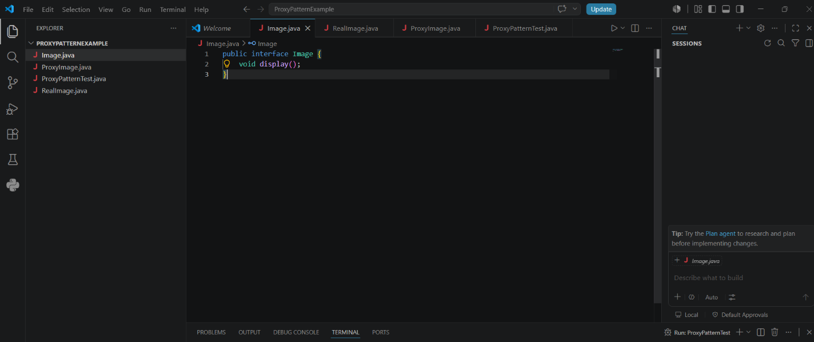

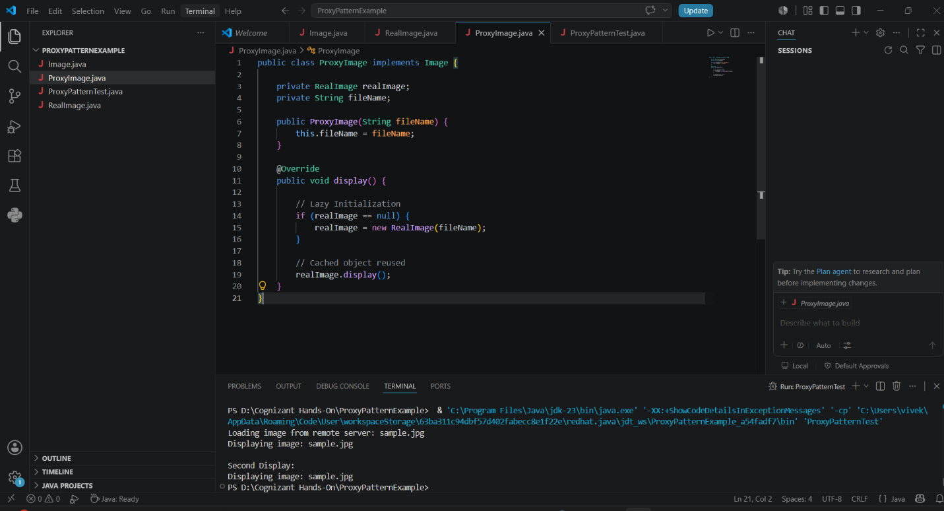
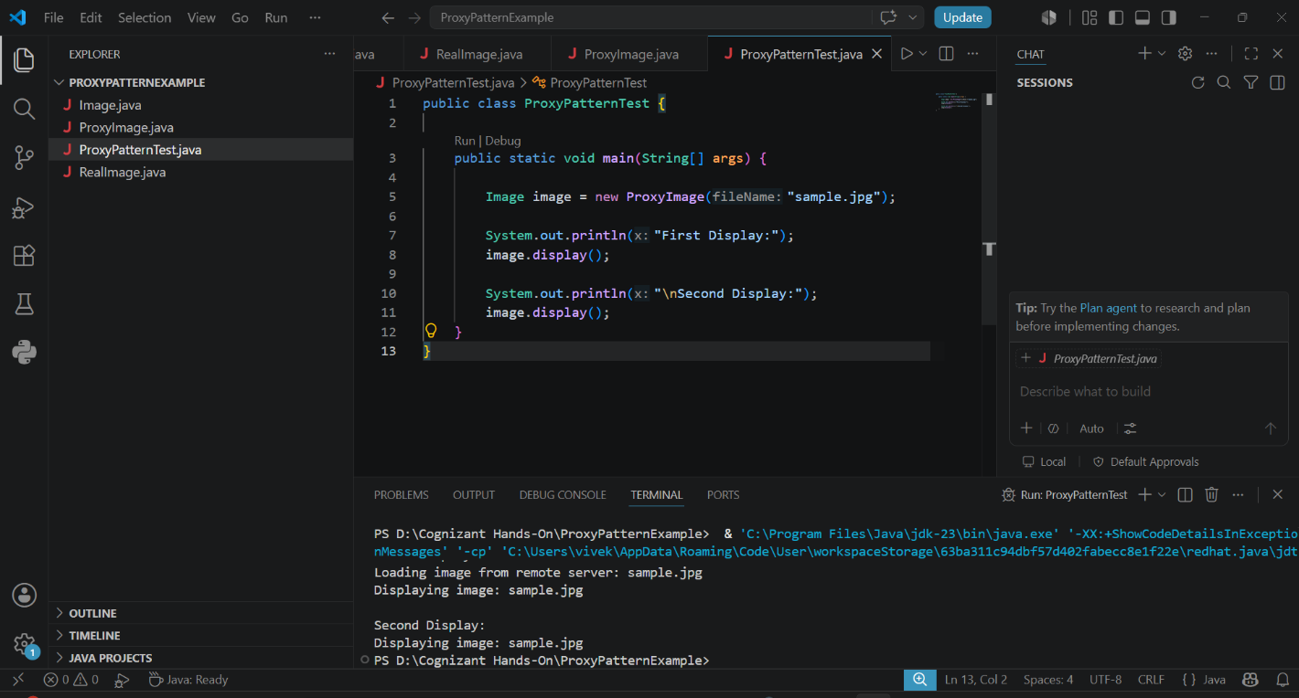
Output:
